Worm Activity Review: Name: ________________________________Per.____

Worms eat detritus (dead bits and pieces) and are found within the soil, some are found partly on the surface and the rest of their bodies are found just under the surface. Birds are the main prey of worms and eat them as they see them from ‘hopping’ around on the surface of the ground. During times of heavy rain, worms are at the surface otherwise they will drown and during times of drought the ground is too hard and they can not dig into the soil. Either way, worms need to be camouflaged otherwise they will be eaten.

Activity: Weather dependent. We will, as a class, go outside and students (birds) will collect as many ‘yarn’ worms as they can find within a given amount of time.

1. How many worms did you collect? ______ Was there one dominant color you found more than another? _________________
2. There are multiple genes which give many worm phenotypes for color, we focused on ONLY 4 colors. What type of
inheritance is the worm color trait? ___Polygenic____.
3. During stable environmental times (average rainfall occurs) medium brown worms are the most common phenotype to all
other worms. But a severe drought has occurred for the last 2 years and much of the native grasses have gone dormant and
turned yellowish and the soil is tough.

→ Which worm phenotype would be most common during this time? AND WHY?
The creme color worm, as it blends in with the yellowish grass and all the worms could not dig into the soil.

→ Using the provided graph below show how natural selection will affect the relative frequency of phenotypes of the worm
population. SHOW 2 lines, before the drought and after the drought & make sure the graph is complete
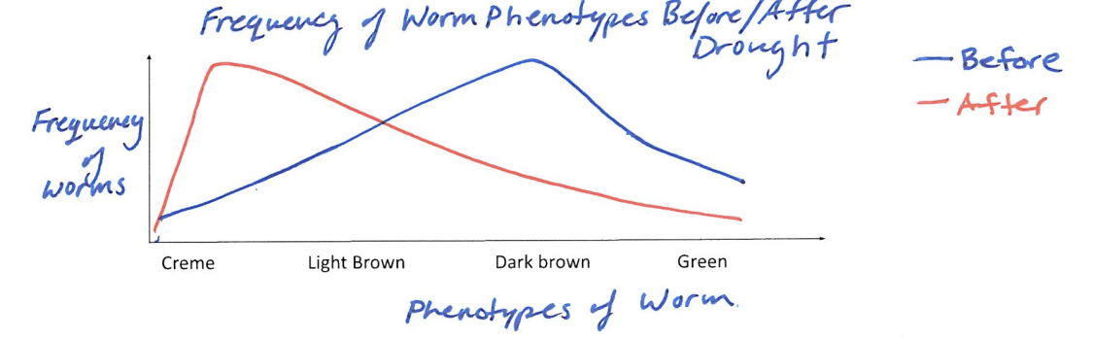
4. What type of selection is being shown on this poygenic trait? ___Directional Selection___
5. Would the phenotypes of the other worms disappear from this population during the drought? __NO__ WHY?
(Use the words phenotype, genotype, and frequency of alleles)
The frequency of alleles will change and phenotypes, like green, will be less common. The alleles will still be in
the gene pool as the environment acts on phenotype not genotype.

6. How is ‘nature’ selecting (enviromental pressure) for whether a worm survives or not?
The amount of rain the environment receives. More water = more green/ plants and softer soil

7. How is ‘nature’ selecting (enviromental pressure) for whether a bird survives or not?
The amount of worms the birds get, based on how well the worms can blend in or dig in the soil.
and/or
Competition between birds going for all the worms that can’t dig within the soil.

8. In a different area, in someone’s nicely manicured yard, the ‘yarn’ worms are thriving and once again the dark brown worm is the most common in the yard. The owners took an extended trip (2yrs long), but unfortunately the automatic sprinklers failed. Half of the yard still received plenty of natural water and the grass remained green, but the other half died and the grass turned yellow. The brown were caught in the middle and did not survive very well.
→ Using the provided graph, show how natural selection will affect the relative frequency of phenotypes of the worm
population. Show 2 lines, before the owners left and near the end of their trip & make sure the graph is complete.

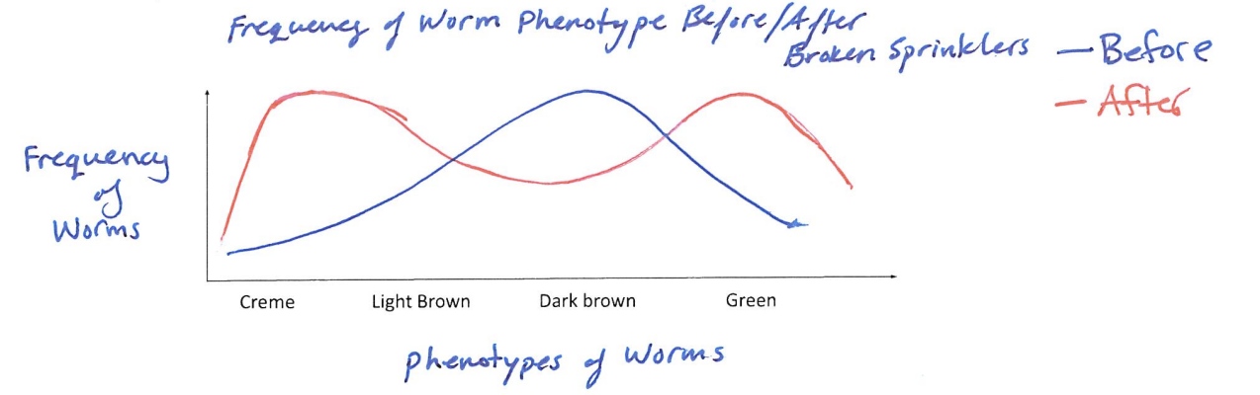
9. What type of selection is being shown on this poygenic trait? __Disruptive__
10. When the owners returned, they watered properly, the grass grew back and all was returned to normal. The yellow and green
worms now lived in overlapping areas with each other but yet did NOT reproduce with eachother. The type of isolation seen is
__Reproductive____ which occurred through __Geographic___ isolation
11. Describe/Give evidence on your answer above.
The green and yellow worms were separated from eachother based on the difference in environment, which is
geographical. When back in overlapping ranges there was no reproducing between the different colored worms
(could be behavioral) but the worms are not reproducing = reproductive isolation

12. Isolation like the above could be demostrating the process of ____Speciation_______

